Regional Workshop

On

Single Women’s Land & Property Rights

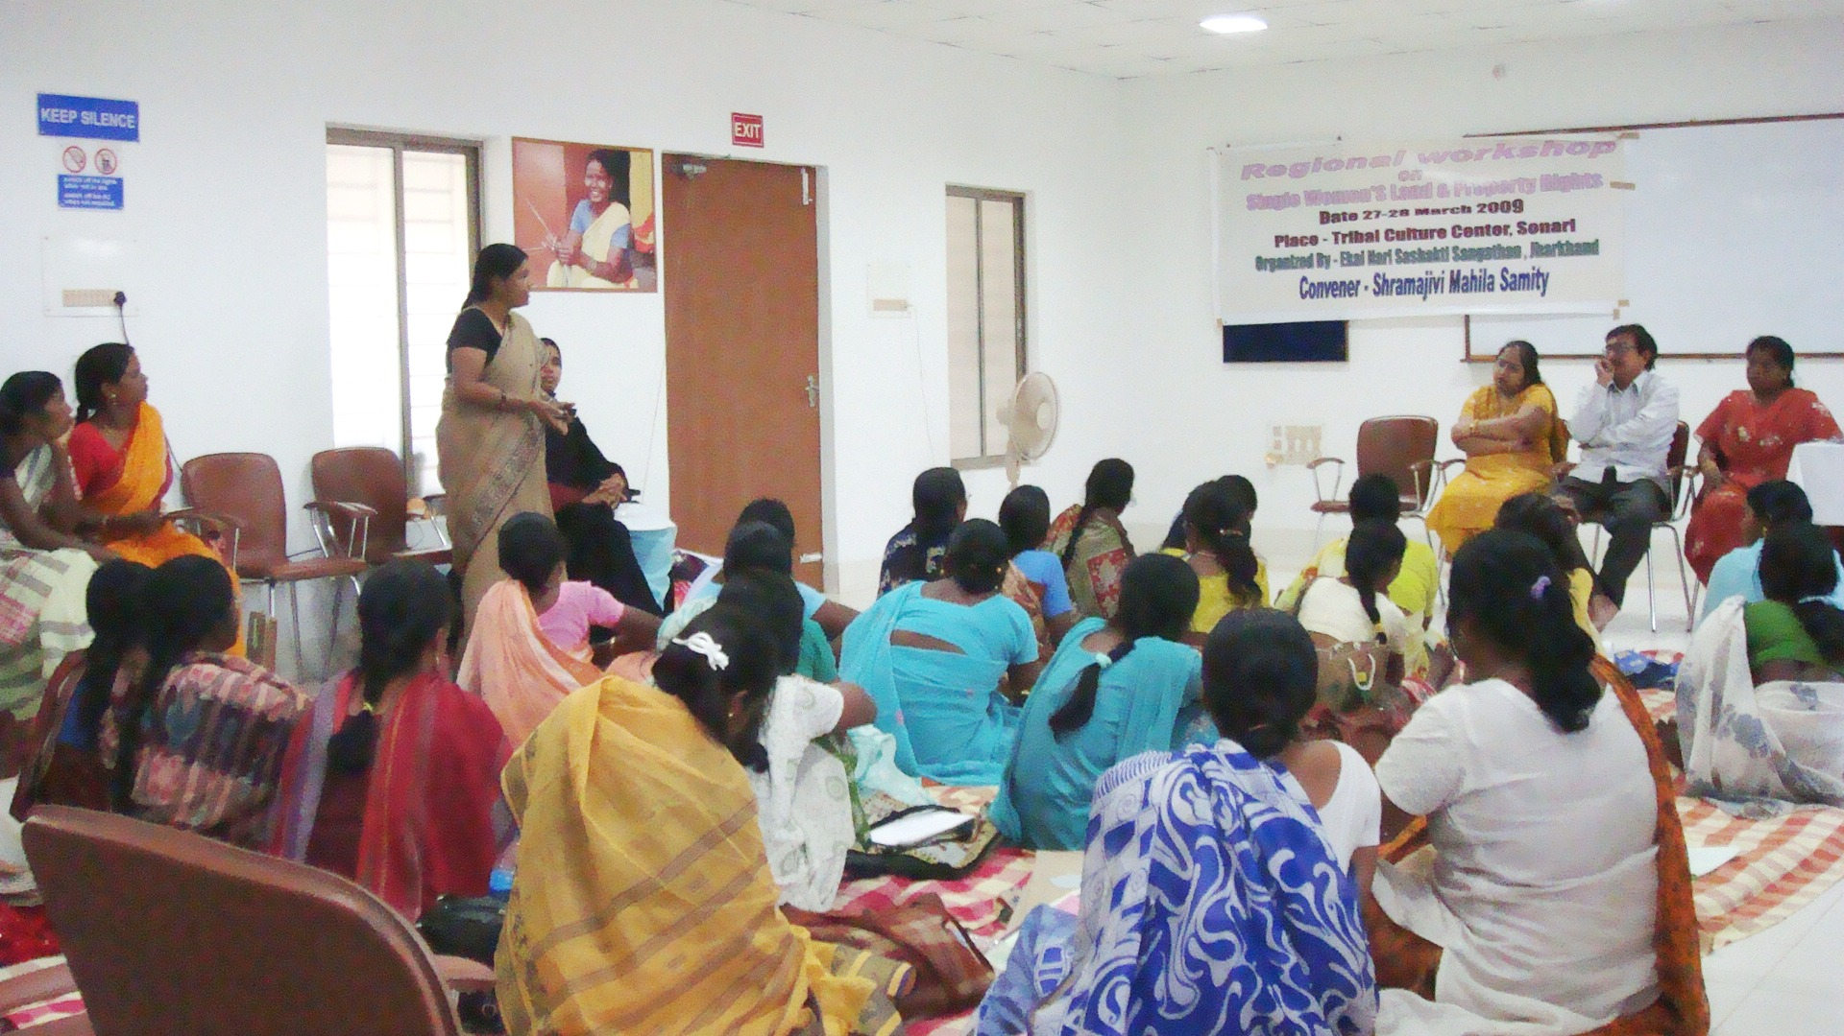

Date: 27th -28th March 2009

Organized by – Ekal Nari Sashakti Sangathan, Jharkhand

Background:-
The Indian woman is the exploited section in the Indian society. The paternalistic form of the society senders her as a tag to the men associated in her life and refuses to offer her individuality. Hence the modern global society also reflects that the women do not have an independent existence. The single women are the worst sufferers. They carry the barriers of social evils, customs traditions and taboos.

Like any other fundamental, constitutional rights these single women also hold the rights to land and property. The land and property rights of the single women too are unequal and unfair. They fend to get less right or rather no right in property than the men both in terms of quality and quantity. Ironically, the fact is that cutting across all disparities of caste, creed, status, class, the property and land rights of the single women rather all women are immune from constitutional protection. Even though the women enjoy ownership of property to certain extent but then the limitation of no power of alienation is exercised upon her. Hence it is a tragedy that possession though conferred alienation rights are curbed in 99% of the cases.

Keeping all such circumstances of the land and property issues of the single women, the Ekal Nari Sashakti Sangthan carried out a survey and glaring facts surfaced the not even 1% in their name and unable to utilize the same. Hence it was decided to carry out an intensive study on the issue of “Land and Property Rights” of the single women at the regional level through a workshop.

Objective:-
- The main objective is to spread knowledge and information regarding the emerging need of land and property rights for single omen among various women headed organizations, networks, associations, CSO’s working for the cause of single women at the regional level.

- The other objective is to share and mutually extract legal directive and policies pertaining to the land and property rights of single women framed in the states of Jharkhand, Bihar, Orissa and west Bengal.

- The final objective was to come to a common platform at the regional level and take a firm stand so that strategy planning for future course of action can be done towards the land and property rights of single women.

Workshop Inauguration/ Introduction
A regional workshop on the land and property rights of the single women was organized between 27th – 28th March 2009 at Tribal Culture Centre] Sonari, Jamshedpur by the Ekal Nari Sashakti Sangathan, an association for single women in the state of Jharkhand.
The workshop was declared open with the welcome address by Ms. Rita Patro from Shramajivi Mahila Samity. It was followed by a brief introduction of the dignitaries, resource persons, participants of the workshop and other representatives present. After the introduction, the secretary Shramajivi Mahila Samity (SMS) Ms. Purabi Paul presented the background, significance and brief activities of the Ekal Nari Sashakti Sangathan. Her presentation focused on the ENSS association that work for the single women who have come together to form an association and strive to work towards their identity and access to their rights and dignity. These women are single by virtue of divorce, judicial separation, desertion, widowhood, no marriage and spinster. The association is spread over 18 districts comprising of 38 blocks having 9000 single women. As its members, she asserted. Further she detailed the activities and the ongoing work of the ENSS association.followed by a brief tea break.

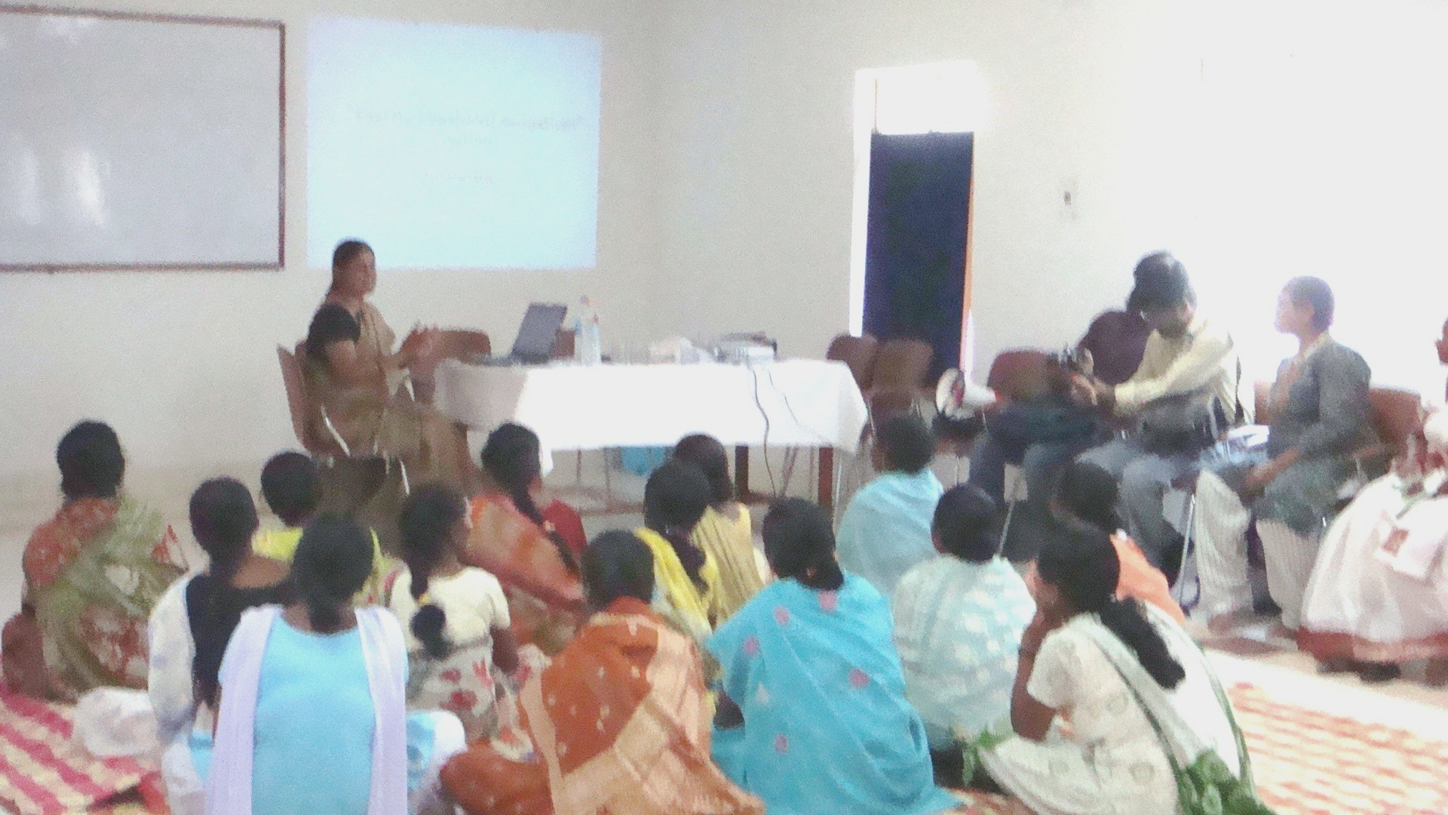

Ms. Purabi Paul made the presentation on the significance of the workshop, its purpose and objectives as to why land and property rights should exist for single women. Rather she owed the emerging need for such a workshop to a study made by ENSS pertaining to the land and property issues of single women in the state of Jharkhand. She stated that the study was conducted on 1029 single women wherein two methodologies were adopted for study purpose. The cases and the specific issues were collected and documented while in the second methodology a random survey was conducted. The sample was classified as such.

Type of Single Women:-
Widow | Unmarried | Destitute | Abondoned | 1029
409 | 211 | 320 | 89 | 1029
Age Group:-
19-25 | 26-40 | 41-55 | 55-70 | 1029
242 | 368 | 233 | 286 | 1029

Community:-
ST | SC | OBC | Muslim | Others | 1029
334 | 339 | 266 | 64 | 26 | 1029
Type of Cases:-
No Share | Disown | Dispossession | No Registration  &  Mutation | Sold to Others | 1029
314 | 324 | 248 | 79 | 64 | 1029
Problem Effective From:-
2-5 Yrs | 6-10 Yrs | 10-15 Yrs | 15-20 Yrs | 1029
356 | 343 | 198 | 132 | 1029

The sample of 1029 single women included 334 Schedule tribes, 339 Schedule castes, 266 OBC’S 64 Muslim women while 26 were others. Their age group ranged between 19-70 years. Wherein 409 widows, 211 were unmarried women, 320 were deserted by their husbands while 89 single women had been legally separated. Out of 1029 single women 314 were such that they did not get their share in the landed property while 324 were refused land possession. 248 single women ere not get land entitlement. 79 were not fortunate enough to have registration of land in their names while 64 were such whose land hare of land was sold fraudulently. These women faced these hardship since the last 0-20 years and were unable to overcome it.

Random sampling on 100 such single women reflected strutting facts and findings; she asserted. 51 such women were agriculture labourers, 24 were engaged in batter and trade whereas 4 of them worked as maids. 15 of them worked as cooks whose daily wages ranged between Rs.20-60. 50% of the women only got work through out the years. They have no savings as such 26% of such women had land in their name wherein carried out agriculture. 13 women asserted that they had no land but work on those land owned by their husbands. Only 9% of the single women stated that they had the land title transferred in their names after their husband‘s demise. It is a tragedy that only 60% of the women are ensured of their future security.

Area covered
District | Block | Village | Tola
13 | 30 | 61 | 44

02) Profile of the sample / Participant
No of Women | Age Group | Cast | Family Head
100 | 27 - 65 | ST – 42  SC – 66  OBC – 46  Other - 06 | Women | Men
100 | 27 - 65 | ST – 42  SC – 66  OBC – 46  Other - 06 | 62 | 38

03) Economic Status
Occupation | Income |  | Work Duration  Annually | Mode of Expenditure
Occupation | Daily | Monthly | Work Duration  Annually | Mode of Expenditure
Maid - 06 | 62 | 32 | 12 Mon - 58
Agriculture Labor - 51 | - | - | 06 – 10 - 24 | Family - 56
Business - 24 | Week | 2 | 02 - 04 - 14 | own – 40
Cook - 15 |  | Yes | No - 04 | 04

04) Saving’s
Yes | No
61 | 39
Yes
Bank Savings | SHG’s | Asset Purchase |  | Money on Interest
Bank Savings | SHG’s | Gold | Silver | Money on Interest
35 | 26 |  |  | -

05) Land & Property

Land Area | Ornaments |  | Agriculture Tools | Animal Wealth | Utensils  Copper/Bronze | Fixed/Ins
Land Area | Gold | Silver | Agriculture Tools
No of women  26  Husband name-13  Self-9  Gov-4 | 19  Both- | 13  8 | 19  (Hasua, Kudali,Hal) | 49  (Hen,Duck,Gote) | 58 | 13 (LIC,SAHARA, fix)

06) The property is under my custody and utilized by me.

Yes | No | No Response
33 | 22 | 45

07) Care and protection for future-

Family member – 4
By Son - 6

08) No asset! How do feel?

Secure | Insecure
06 | 50

The aforesaid straling facts and figures / findings paved the path for the need of such a workshop, asserted Ms Paul, she stated that the present status of single women is worrying hence future course of strategy is to be made. She also sacked support of the participants in the workshop to adopt collective measures toward he emerging land and property issues of single women in the two day workshop. The session was dispersed for the tea break.

After the tea break, the workshop began with the takeover of the session by Mr. Praveer Peter, representing the forum of Gender, Resources and livelihood. In the backdrop of the background laid for the land and property rights of single women he stated that there is no such written policy or code so far land and property rights is concerned in the society. There are different beliefs and thoughts in different faith, caste and community pertaining to the agricultural land and property. As such there are no traditional laws in favors of the women class pertaining to their access and right to land and property.
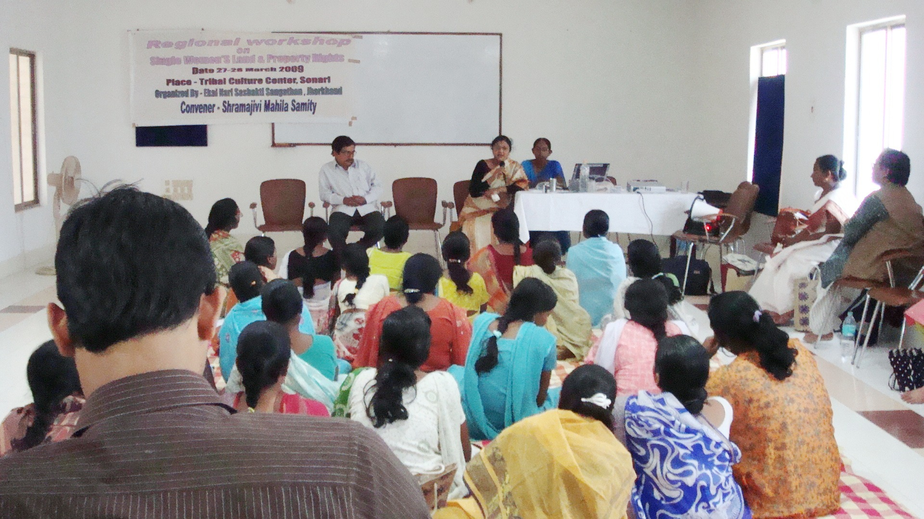
Though the Adiwasi community is guided and directed by its traditional system / Rules which is a good practice. The daughter does not get her share of property in her father’s share of property and ancestral land. The said property also cannot be transferred in the name of the daughter. But their, the unmarried daughter is allowed to rightfully use the property of her father as per the custom and tradition. The widow’s adivasi women and their children do not get the further in the santhal society, the majority of the unmarried women are designated as witches as they mostly reside in their parental house. The motive actually is to disown these women from the property. The traditional laws are not in favour on the women. Referring to the customs of the Santhal Adiwasi, he mentioned that Taben – Jom is a unique practice; according to which the daughters had a small share in the father’s landed property which was not as their rightful right rather depended on the personal choice of the father. This was a tradition only for the married daughters wherein whenever she came to her parental house she was provided all hospitality from the share of the aforesaid land. But this custom does not hold true any house. The further stated that only 10% of the Hindu women are able to access their right over their father’s assets and property though they have been entrusted such right. The social pattern of the Adivasi community is such that the decision making capacity with respect to landed property lies with the village head. Moreover the men do the work related to the block/court/bank. Ultimately the habit of alcoholism provokes them to sell their land for a meager amount. The measure of development is not structuriesed in the Adiwasi community and is based on decision process. About 150 years ago books were written on the traditions and customs of the santhals and Adiwasi society which is believed as a law book for the Adiwasis in the present times. The traditions are not being adhered to in the present days and are being broken day in and day out which is a hurdle for the adiwasi women. He further added that the state level Adivasi Advisory committee should come forward and take the initiative to ensure that the Adivasi women are able to access their rights. The Central Government asserts that the women have a joint entitlement over the land and property that are in the name of her husband; hence the women can get their names inserted in the land palters and land records at the time of renewal. The plight of the women does not end here. They are not considered as farmers hence banks refuse to sanction credit and loan facility to the women. It the women hand land records in their names, then they are better equipped to each their livelihood out of these property. Referring to his experiences he mentioned that the men in the rural areas are perhaps willing to share the land pattas with their wives and hence are taking initiatives to get the names of their wivies inserted but the men who belong to villages adjoining the urban area refuse to do so. The main reason behind it is that they feel that the benefits floated on account of rehabilitation will move to the women and they will be denied any benefits as such. The session was broken up for the lunch break.
After the lunch break the second session commenced with a folk song. After this the Human Rights Advocates Network Representative, Ms.Vasavi Kiro took up the session and addressed the gathering.
She began with the basic fact that land rights and property rights of a citizen are two different issues. The land pattern and its structurisation of the Adivasis has been defective right since the times of the Britishes. The land arrangement and land records making was got done from people who did not know land measurement. They were ciphers and did not understand the length and width of the land at all. She further added that there is no dispute at all over a piece of land till it belongs to a community. As soon as the entitlement of the land is awarded to an individual lot of questions and queries regard its actual possession is raised. The CNT Act was enacted in 1908 wherein adivasi cannot purchase the land of an Adivasi. But certain amendments were incorporated in 1945 in the CNT Act so that the Adivasi land could be sold and purchased with case. Land, trees and crops are not considered as property in the Adivasis but are considered as life’s philosophy. Hence she raised a question then how come the land that belonged to the Adivasis was sold in the existing circumstances? This has led to the illelegal transfer of 14,00,000 acres of land plots under the CNT Act.

She further asserted that as per the traditional Adivasi laws and unmarried woman has the right and authority over the crops grown in her father’s land. Again the customs, laws and social traditions of the Adivasis have not been documented which needs to be written now. The unwritten customs and laws are not put into practice at present. She cited the example of Dr. S. Bolastica who gave his land and its possession in his daughter’s home. After his demise his daughter faced her kith and kin with revolt and finally a case was filed. The court admitted the authenticity of the land in his daughter’s name and finally the land ownership was bestowed upon her. She then cited the example of novelist Nirmala Putal whose mother gifted her piece of land plot wherein she constructed a house. Since Ms. Putul was an eminent personality hence did not face much revolt. She got her legitimate right after a long struggle and fight.

She stated that women can be the custodian of the husband’s land. There should be a thorough discussion as to who should be the authority over the acquired property. She emphasized on the fact that the married women should get equal share in the self acquired property of the husband. The new Forest Act also stresses on the fact of land pattas being named in the name of women. This is in fact a policy decision and no customary laws can be implemented on the same at time of rehabilitation, the house will be in the name of the woman, so says the laws presently enacted. She motivated the participating women (single) to be alest about their rights. She then talked the meet organized by NAWO in 1995 wherein about 2,000 women headed organizations participated in the meet. She made an expectation that such collective efforts can definitely go a long way to land voice to the property rights of women.

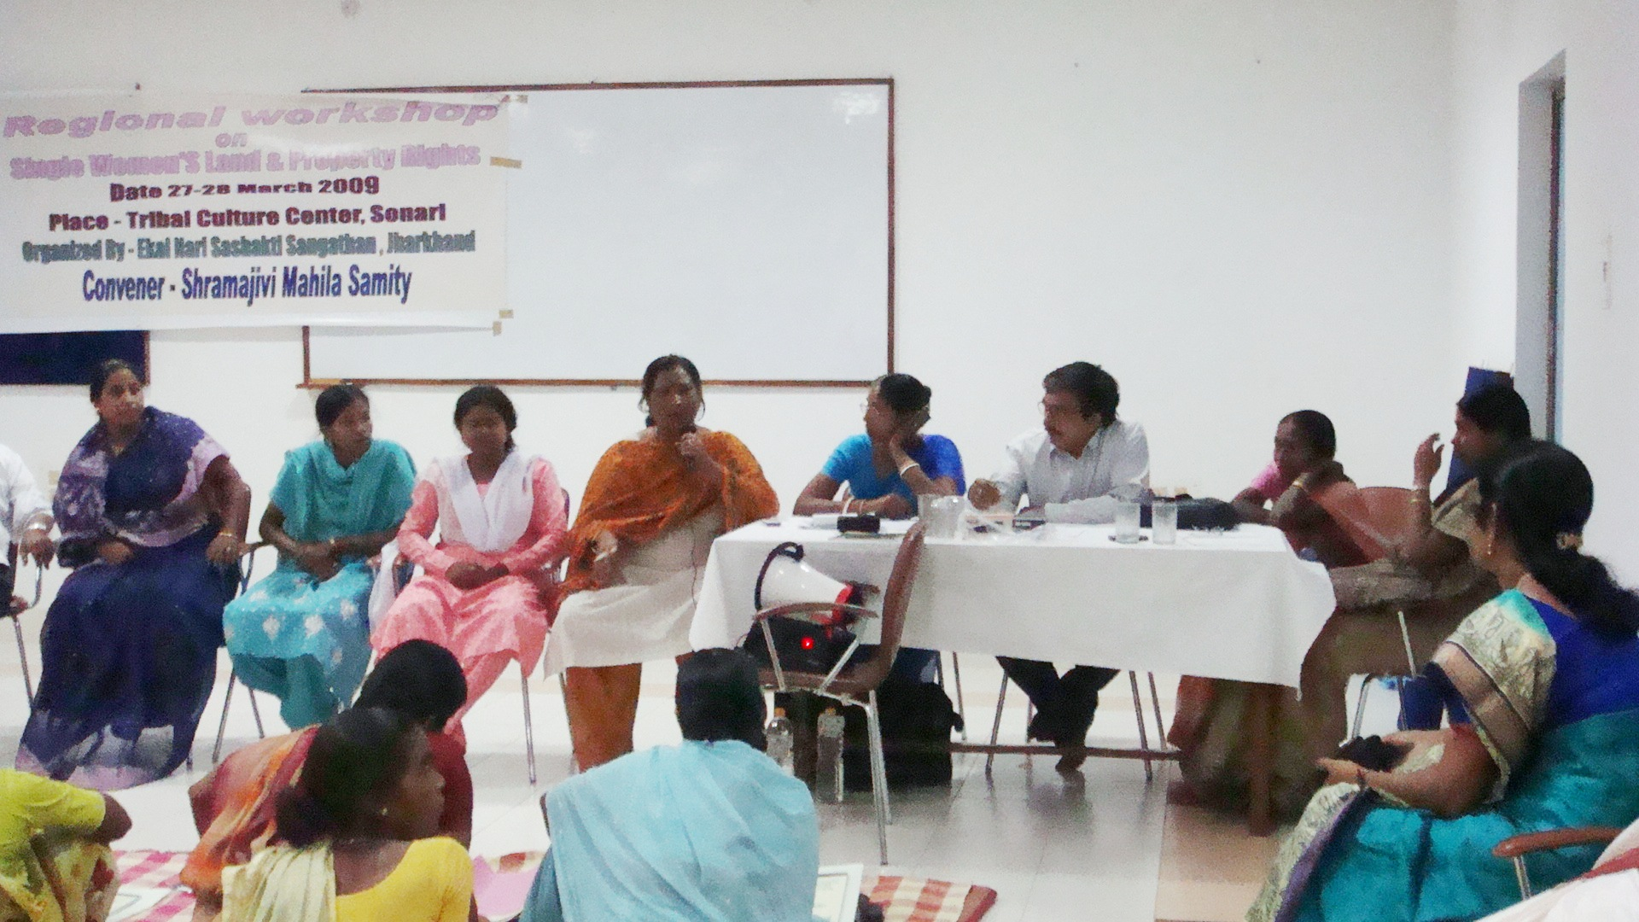

The next session was taken over by Mr. Ajay Mitra, our resource person who is an active practicing advocate at the Chaibasa Court with vast experience in land matters. He gave out necessary inputs relating to land issues. He stated very significantly that 1) The adivasis can self sell their land only to such people who reside in the same police station area wherein the land is situated. 2) The village head (Munda) has to give his recommendations at the time of land sale which is then decided by the Deputy Commissioner.

Further another condition is that 3) An adivasi can sell his land only if he retains a minimum of 3 acres of land even after sale so that he can earn his livelihood well. In order to keep a check on the discrepancies involved in the sale of land the circle officer has been directed to submit reports regarding land sale to ensure genuinity. With this Mr. Mitra told the gathering to clarify their queries regarding land rights of women. This was in the form of a Question – Answer session.

Question – Answer session:-
Q. To what extent do the women hold rights over land and property in the legal frame work?
Ans:- The Hindu Act grants equal rights to the daughter in the property of the father. The Hindu act requires the presence of the daughter as one of the share holders in the joint property at the time of the legal division of the property. Hence the property occurs. Further he stated that the grand children cannot claim rightful share in their grand father’s property till he is alive. On the other hand they can definitely claim rights on their father’s property.

- Ms. P. Paul enquired that even after having legal rights over the property only 10% Hindu
women have been able to access their rights over land. Why is it so?
Ans:- He answered that the old Khatiyani rights and documents contain the names of all family members – father, mother, son, daughter etc. In fact it is the women who are to blame who do not come forward to demand their land and property rights. They will themselves have to come forward and raise their voice against discrimination in getting their land entitlement.

- Further Ms. Paul enquired that not even 1% of the women have ownership over their land and property. Is it because thee is no awareness among the women or they are not willing to demand heir rights for fear of spoiling their relationship with their brothers and cousins?
Ans .Mr. Mitra answering the query stated that at the time of land pattas being written, each family members name needs to be incorporated in the mutation documents. After the death of the father the son ha to getting his name entered. The sister has the authority to file a title suit after the death of her father. She can claim title if the brother sells the land without taking her permissions and decision.
- One of the participant enquired whether a women can get loan in the name of her land ?
Ans. Mr. Mitra replied that if the revenue is being paid and the receipt is in the name of the woman then the concerned woman is entitled to get loan against the said land. The revenue is paid in the circle office of the district.
This was followed up by a briefing of the entire day’s proceeding by Ms. Binny Secretary of SHARC.

At the end of the session an open house discussion for sharing views, opinions and experience of all the people present whether resource persons, participants, or organizers as to what can be the way out so far granting land and property rights to the women is concerned. All the participants representing their respective states put forth the present position of the women concerning their property rights. The views are expressed as hereunder:-

The representative from Mahila Maha Sabha, an organization from Jhasugoda, Orissa stated that the women have been granted legal rights in land and property of the family but the girls whether daughters or sisters do not demand any share in the paternal property. They have equal share according to the law of Orrisa. Mr. Peter from GRLF added that the Kharia tribe of Orrisa grant land rights to the Women and they have very much acquired it.

Further Akhtari Begum representing CSO from Motihari district in Bihar said that she has been working on the land issues of women in East and West Champaran and some parts of Darbhanga. She added that a committee has been formed to settle the problems of the land disputes. Herein a task force has been formed to continuously monitor the functioning. Talking about the Mukhopadhayaya committee and its recommendations are implemented she stated that if the recommendations are implemented then the land allocated in the Bhoodan movement will actually go to the right beneficiaries. Further she applauded the initiatives adopted by the Government and mentioned that the “Doms” and the “Mushars” communities and other deprived castes have been identified and provided residential small pieces of land. This residential land has been given to the landless people. But she also expressed resentment over the fact that though the women have got land rights in Bihar still they face the same situation in Jharkhand, she emphasized on the fact that advocacy is the emerging requirement to ensure that the women get their access and rights over land and property.

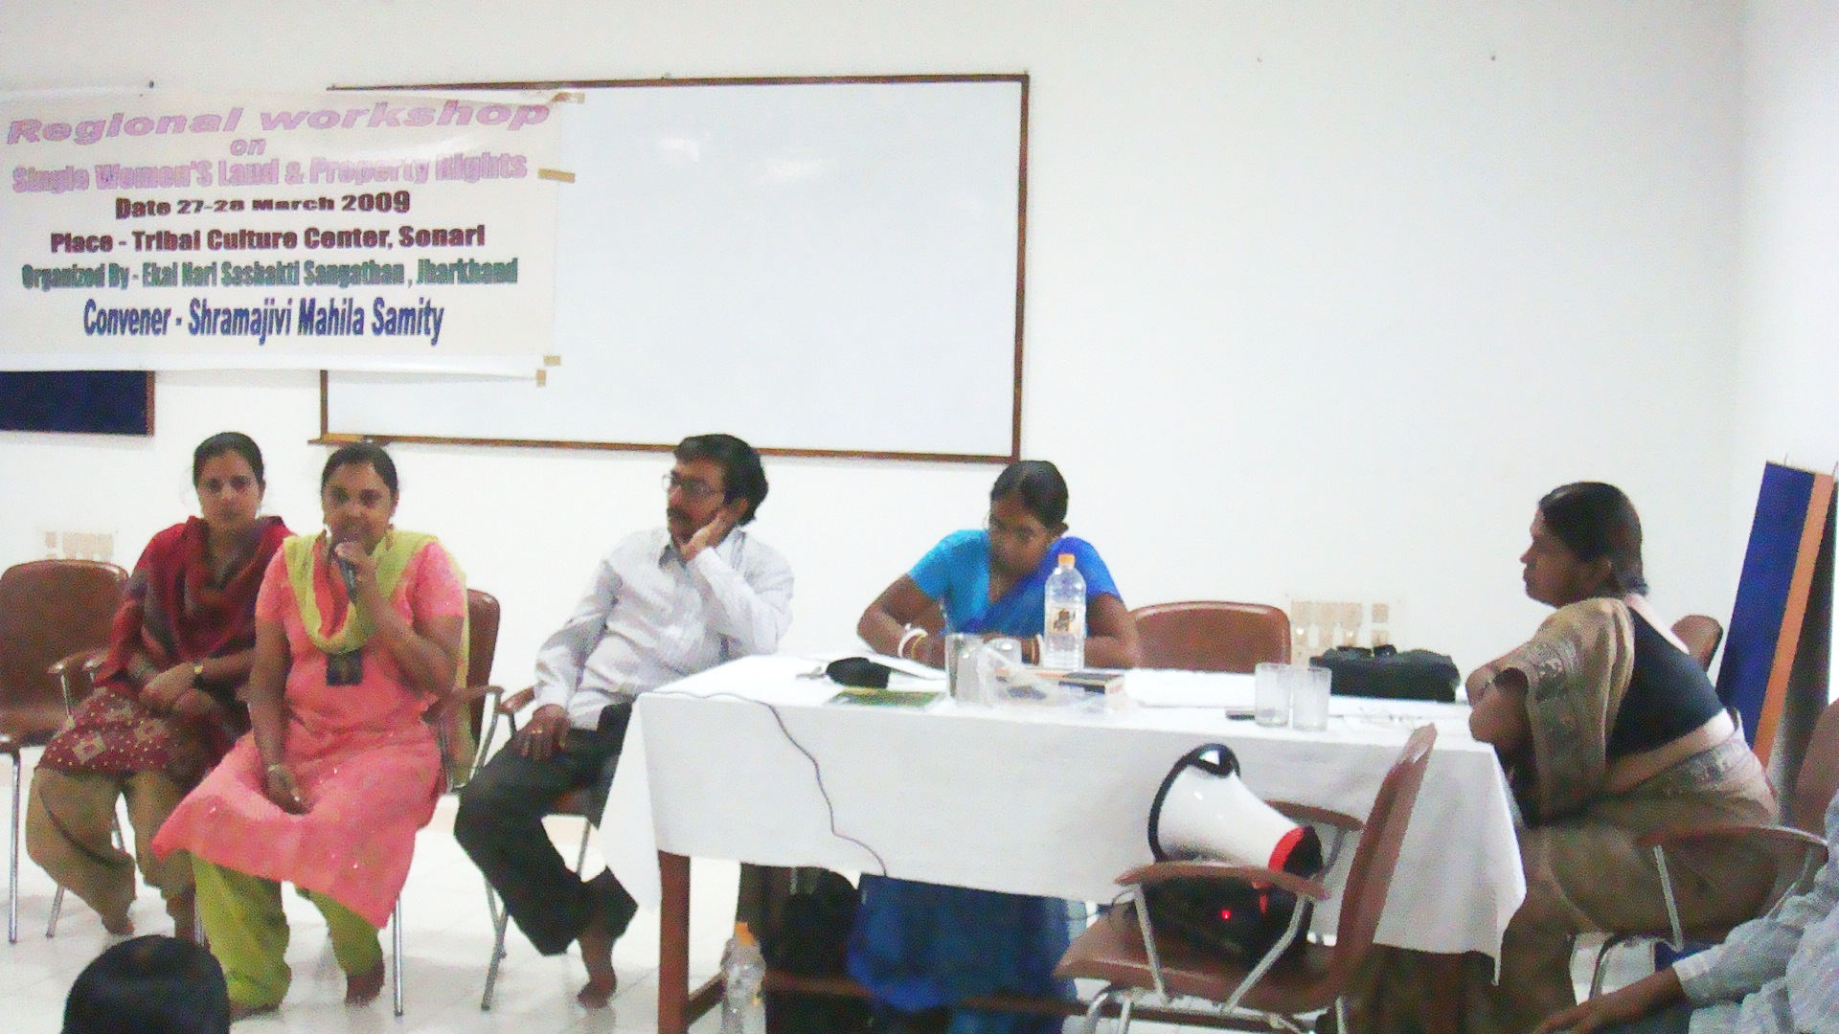

The representative from Bengal Mr. Nirman Hazra said that the women in Bengal do not have such easy access over the land and property unless and until they do not fight long legal battles in the courts and out of courts. The subject and issues of the workshop are no doubt very important. Hence it is important that such issues should be brought to the national forums for awareness.

The representative from “Nari Vikas Sangh” Bankura, Ms.Champa Sardar and Balika Sardar mentioned that they jointly formed the women federation that works for forest plantation and livelihood out of it. The forest department has granted fund to the federation to plant trees. The federation is on its way to make efforts so that the land in which the federation has planted trees is allocated to the women. Citing an example of a case wherein he had given some portion of his land to his wife. They had two daughters. The wife and the daughters took up the cultivation work on the said land. After the demise of the wife, the brothers seized the portion of land given to the daughters by the father. The dispute went to the Gram Sabha wherein the brothers raised question that the Adivasi women do not get share in the parental property. The Gram Sabha decided in favour of the brother. The sisters filed a title suit which they lost as the court decided according to the traditional and customary laws. The situation is such that presently the two sisters are bereft of their land.

With this the first day workshop came to an end and it was decided that all such problems and issues pertaining to the land rights of women will be taken up and recommendations would be laid down to solve these issues.

The second day of the workshop began with a thoughtful song followed by a brush up of the first day proceedings by Ms. Purabi Paul.

The first session commenced with a detailed presentation of the statistics and data related to the present status of the property rights of women in the South Asia Region. The secretary, Ms Purabi Paul of SMS stated that government NGO’s and CBO’s should collaborate to build support networks for Single women on equal land rights. These are needed at the national level and put into practice.

After the presentation, the single women present in the workshop presented their cases and issues which are as herein under,

Case I
Vidya Murmu from Godda district narrated that after her husband’s demise, her sister-in- law threw her out of the in-law’s house along with other members of the family. They alleged that since she did not belong to that area and hence she had no right to reside after her husband’s death. She was assigned as a witch who led to the death of her husband and two children of the neighborhood. I filed a case in the court but all the documents relating to the land was burnt by my sister-in-law. All the revenue receipts are in his father-in-law’s name and still she was denied any part of the land. The case is pending for the past four years. Her brother-in-law alleges that since her husband was the adopted son, she had no rights over the land and property.

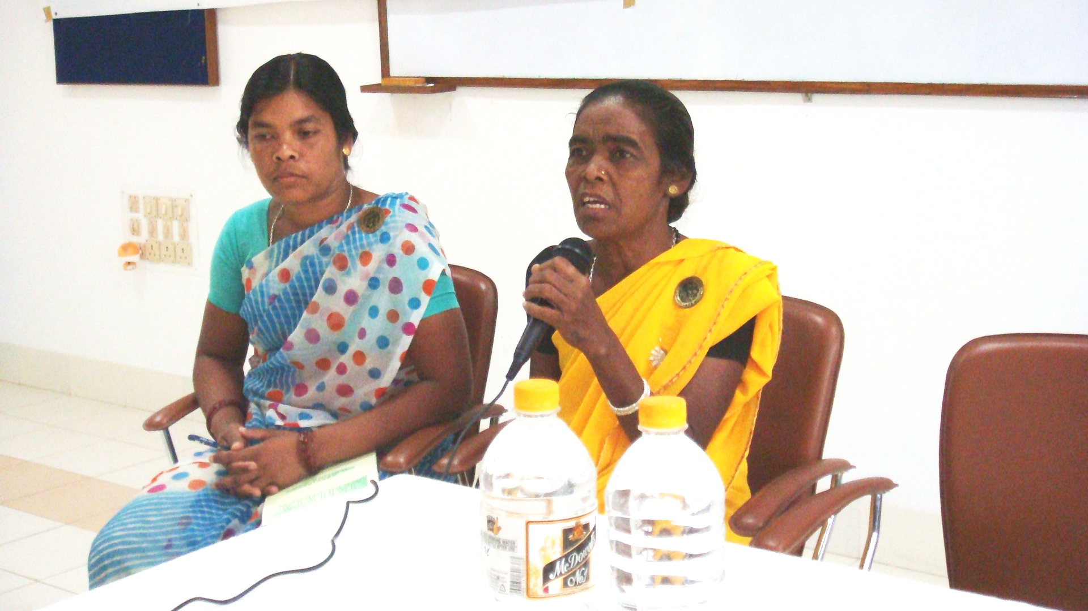

Case II
Samema Khatoon of Simdega district narrated her story that she was married at the age of ten years in 1966. She had three daughters out of marriage. Her father-in-law’s sister protested that she should not be allowed to reside at her matrimonial house though the father-in-law raised objections. But after three year’s of her husband’s death she was separated from the house. At the time of separation of the house she asked for her share but her brother-in-law refused to part off any share on the plea that the grand children have no legitimate right over the grand father’s property. She filed a title suit in the Lok Adalat wherein all of them deposed as witnesses. Further, the Lok Adalat directed her to get fatwa from the Imaam Shariyat from Ranchi which could only possibly decide the matter.
Suggestion: The resource person and advocate Mr. Ajay Mitra replied that the grand child will not get any share in the property of the grand father as per the Muslim Customary law. But the law gives the legitimate right to the grand child of share in the property of the grand father. He suggested them to file a title suit instead of a case in the Lok Adalat wherein they would get justice. Referring to a judgment from the Supreme Court he stated that the legitimate wife as well as mistress of the husband will get due rights in the property of the husband.

Thereafter an open discussion was held wherein all the participants came out with their issues. Anticipating the common problem with the single women, Kalyani Meena, the representative from Prerna Bharti put forth her views as under,

Kalyani Meena: She stated that the present situation says that the registration of marriages is very much compulsory as the legal acceptance of marriage has taken dominance over the social marriage. If the marriage is registered, the woman can fight the challenges emphatically when her rights are infringed upon. She then further clarified that presently the land of the Adivasis have been allotted in the name of individuals rather than the individuals who are men exclusively. Thus property rights can be legitimately accessed only if the marriage is registered. Mass awareness should be undertaken at the Gram Sabha level in the rural areas.

Purabi Paul: She queried whether the lacunae exists only due to the lack of awareness or any other factor is responsible as well?
Kalyani Meena: replied that the group mobilization is very much important to the grant pace and movement to the legal system as well. For example, aspects like linking up legal forums with Human Rights Legal Network with the women relates suits and cases. Further, a concrete decision is to be taken so that awareness and mass campaigns to change the mindset is done. Mass appeal is to be ensured to have a sound social pattern. If the women take up dual responsibilities then they are entitled to get due share in the resources as well. We shall have to develop mass appeal for which knowledge on our past is very much needed.

Purabi Paul: She lamented that the problems of all the women are alike as we are attached to an organization. Hence we need to know too many rules and regulations. Wee should link ourselves to many networks and gather knowledge besides updating the masses with legal knowledge and information.

After a brief tea-break the resource person from Johar, a Human Rights Organization, Mr. Ramesh Terai introduced himself to the participants and updated them with inputs relating to their activities in the organization.
Addressing the workshop he stated that we shall have to begin with comparing the position of women in the present circumstances with that in the early days in the history. The present legal system in the welfare of women should also be studied as to what can be done to ensure property rights for women. He further stated that before the development of the civilization, Jharkhand envisaged maternal form of society. At that point of time women possessed limited knowledge which provided undue liberty to men and they transformed the social set up to paternal form of society. However, the Ho tribe initiates any form of religious ceremony with women. The archeological facts of the Adivasi society reflect that they had a maternal society. Before independence, there was no land dispute between men and women. The government initiated it to collect settlement taxes. The settlement of land was only done in the names of the male members of the family. Had it been that the name of the women members was also included then there would have been no dispute at all. He further added that if the customary laws are referred to in present circumstances, then the old laws and regulations seem to be faulty. But then the customary law also stands on a particular base guideline.

Mr. Jerai tried to explain that the Adivasi community follows three important customs in their community. He explained the birth, marriage and death customs are followed in the Adivasis in detail as to how ancestral blessings are significant during these three phases of life. He stated that we grant full liberty and rights to the women in the domestic front. On the other hand, men have all the authority to sell their lands as the settlement records are in their names. He added that the land and property matters are very sensitive issues. Mutual discussion with the Adivasis can be the only solution. So far the land and property rights of single woman concerned, there should be a thorough discussion at higher forums amongst representatives of all communities of the society so that a feasible solution emerges.

After his presentation an open house to discuss the views of Ramesh Terai was undertaken wherein all the participants at the workshop presented their views points as follows:

- Sukhumani from Lohardaga district asserted that the Adivasi community single women must demand their access to land and property in the meetings of Panchayat in their villages.
- Ms. Paul from SMS asserted that the woman need legitimate authority over land and property so that they enabled to have secured life and earn their livelihood.

- Kaluani Meena from Prerana Bharti asserted that the people with traditional mindset should initiate and come forward to enable the property rights for women as the women are deprived of their rights on the baseless plea of customs and social structure. She also expressed her resentment that the system is encouraging the customary social set up ie we value the customs and traditions at the cost of human ethics and human values.

This was then followed by a presentation by Manimoy Sinha , representative of Centre for World Solidarity (CWS) an organization serving as a Resource Centre in Jharkhand for CWS , Hyderabad. He addressed the gathering with a brief message that there is no genuine adaptation and adjustment with the social framework and the legal framework of the society. The legal system has changed in due course of time and the social system has also substantially changed. The Hindu Succession Act states that the men and / or the women have equal rights and the parents have the free will to distribute the land and property according to their wish. The patriarchal social system believes that the girl / daughter is the family member of a different family. Hence, though the law supports the girls, they do not have right and entitlement to property either in the rural or the urban set up. The girl being a member of a different family has to suffer. Her relationship extinguishes beyond one generation with her family the woman belonged to.

He raised another vital issue that why people who possess land and property in the society are considered more powerful? On the other hand, a person with no property assets has no identity in the society. This should not be true as the social dignity is also an important factor. Thus, we should have a thorough discussion on the social dignity. Property and assets are not the ultimate factor in granting social identity to a woman. There are rare cases of women getting property rights in the villages and urban areas. He urged the need for literacy and awareness development as an important tool for the women to access their land and property rights.
Mr. Sinha also threw light on successful cases in different districts of Jharkahnd.

Case I
Chameli Devi is a backward class woman of Mundhro Panchayat of Giridih district. She possessed 5 acres of land and two children. She was called a witch when one child died in the village. When CWS started working in the village she was selected as the head of her SHG. Chameli Devi strived to develop her SHG as a social group and other women were assisted in fighting social curses like witchism and dowry etc. She fought a long battle to tackle the taboo of witchism made on her. Today she is a successful individual earning her livelihood on farming.
Citing such cases Mr. Sinha emphasized up on the fact that continuous struggle should be undertaken for rights. Only 2 % of the women possess right over their land at present. The rest of the 98 % suffer for whom strategies should be developed in the workshop. Three attributes are important so that land and property rights can be ensured for women. These attributes are education, independence of women and continuous efforts to achieve the goal.

Views and opinions were asked for from the participants on the aforesaid statements. These are as follows.
Ms. Purabi Paul asserted that so far the strategy of the workshop is concerned the emerging need is to reach a collective decision based on the two-day discussion. It is the responsibility of all the participants that there should be a mass appeal on the issue so that the society gives a thought on it. The representatives from every state should come forth with the future strategies to be undertaken on the burning issue.

The suggestions that were given by the participants are as follows:-
- The representative from West Bengal suggested that the women should initiate their land rights right from the SHG’s which should be subsequently taken to the forums of panchayat, block and the district level.
- Bal Sonari from Madait organization came out with the suggestion that the legal procedure should be framed and implemented such that the names of both husband and wife should be strictly incorporated at the time of mutation and land records. The names of both should be included in the land and property records at the time of registration.
- Savitri Bodra had a different approach and she suggested that in order to have land rights and entitlement the women should organize themselves and collectively fight the battle for their rights irrespective of our faith, caste and community that only divides people. The assets that are in the name of the husband should be listed out and then joint names of both of them should be inserted.
- Sukhmani Murti – She suggested that the CSO’s and NGO networks have the endeavour to raise any issue before the Govt. and hence we should collect information on the actual data of the single women and talk to the Govt.concerning their land and other rights. There are hurdles in this area as the people have no clear conception about the single women. The Govt.and the people representatives also have myths about single women.
- Shefali Mahato suggested that the single women should themselves be sensitized on the issues of single women which will then help in sensitizing and creating awareness among the general masses.

- “Shruti” and “Mahila Mahabsabha” of Orrisa : The CSO’s jointly suggested that they would collect data as to how many single women are there in their respective areas. Besides they would also publicize and undertake awareness making drives towards the registration of marriages.
- Marandi from CWS suggested that the study and data collected on single women should be published. The case studies should also be documented to that initiatives could be undertaken to hold discussions at the national forums.
- Kalyani Meena suggested that there is an emerging need to work for the single women at the Gram Sabha level. The Govt. has to be sensitized towards single women at the national level so that laws are framed for their welfare. The society is to be compelled to shed the customary pattern of thought of discrimination between boy and girl and the people are made aware of it. It is essential that everyone from the social front come forward to get rid of social taboos and evils.

Outcome/ Conclusion of the Workshop
The two day workshop was concluded with a message that an universal law is framed for the welfare of the single women on a wider canvas irrespective of caste, creed, community or faith whatsoever. It was decided to pass resolutions and recommendations for which a committee was formed. The committee comprised of representatives from various CSO’s representing different states. The recommendations laid down are as follows:-

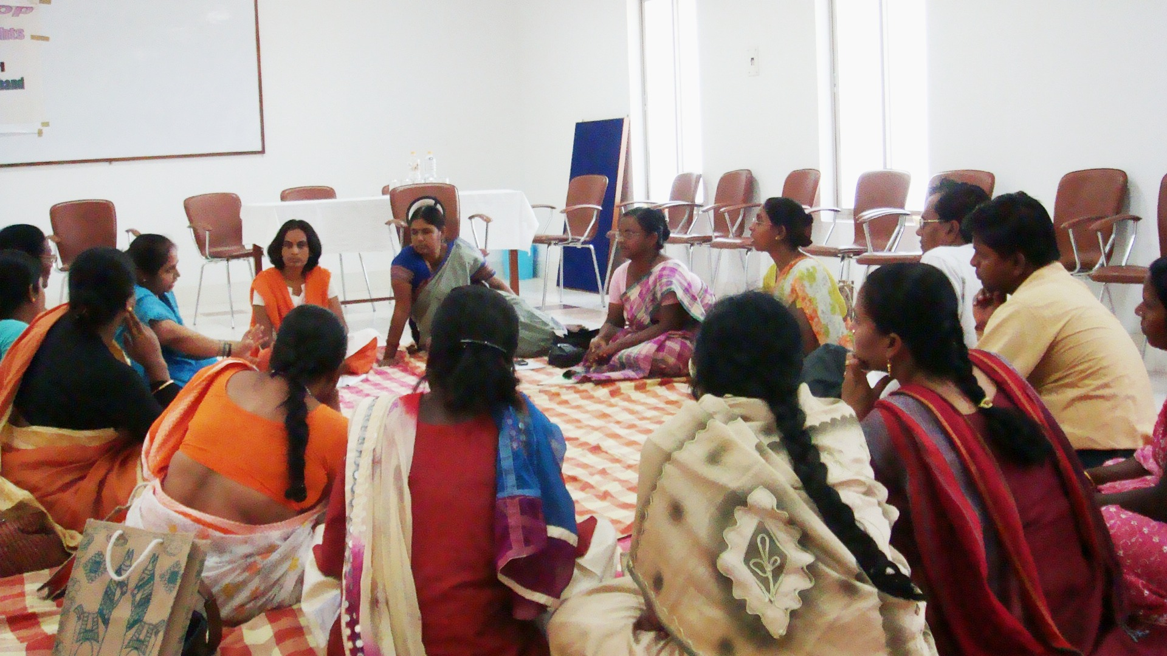

- The Land and Property Act for Women should be universal for all women irrespective of caste, creed, community and status and enacted.

- The Land Records should incorporate the name of the surviving women members of the family as well.

- The provision should be such that in the case of a married woman, after her husband’s death, his name should be struck from the land records and simple and quick process should incorporate the wife’s name automatically.

- The provision should be such that in the case of women with minor children, the land and property rights should be in the name of the women exclusively with the names of dependent minor children. When the children are major the land and property should be equally segregated among the mother and all major children.

- When a matter with respect to land and property is sub judice, the court should reserve its right to permit the concerned victim woman to exercise her right and use the disputed land/property to earn her livelihood till the final disposal of the suit.

- When a single women files a title suit for possession over land and property the act/ provision should be such that:-

  - Such cases should be decided in fast track courts.
  - The incurred cost / expenses and court fee should be reduced to a minimum.
  - In the absence of the disputing opposite parties/respondent the suit be heard ex-parte and decided in favour of the single woman / appellant.
  - The final order be complied and the possession of the property be conferred upon her.

The workshop that ran for two days ended with the passing of these recommendations after the lunch break.
Follow – up action plan:-

The participants felt that sharing was required in the following areas:-
- Legislations pertaining to women’s land rights.
- Policies and schemes related to women’s land rights.
- Process documentation of the struggle.
- Strengthening of CSO’s and people networks
- Advocacy on women’s land rights.
- Equal participation in decision –making
- Ownership to resources and schemes

Ekal Nari Sashakti Sanghathan
Regional Workshop on Single Women Land & Property Rights
Venue: Tribal Culture Centre- Jamshedpur
Date: 27th -28th March 2009

Participants List

NO | STATE | NAME OF THE ORGANIZATION |  | PARTICIPANTS NAME
01 | Jharkhand | Gramoday Chetna Kendra |  | 1. Ms. Sabita Banerjee
02 | “ | Singhbhum Gramin Unnayan Mahila Samity |  | 1. Ms. Sephali Mahato  2. Ms. Sulko Soren
03 | “ | Prerana Bharti |  | 1. Dr. Kalyani Meena  2. .Ms. Usha Kumari
04 | “ | Mahila Mukti Sanstha |  | 1. Ms. Nagia Devi  2. Ms. Leela Devi
05 | “ | Aadhar Mahila Seva Sansthan |  | 1. Ms. Sabana Wasim  2. Ms. Zeenat Jabeen
06 | “ | SERVO |  | 1. Ms. Amarmani  2. Ms. Sukhmani Lakra  3. Ms Chintamani Barla
07 | “ | MADAIT |  | 1. Mrs. Balsonari Tirky
08 | Jharkhand | SHARC |  | - Mrs. Binni  - Ms. Merian Soren
09 | “ | JRC. CWS |  | 1. Ms. Janaki Duby  2. Ms. Aruna Marandi
10 | “ | SANSKRITI |  | 1. Ms. Sanjukta  Choudhary
11 | “ | Mahila Kalyan Samity |  | 1. Ms. Anjali Bose
12 | “ | ENSS, Jharkhand |  | 1. Ms. Sarswati Singh
13 | “ | ENSS, Jharkhand |  | 1. Ms. Subla Devi
14 | “ | ENSS, Jharkhand |  | 1. Ms. Shanti Devi
15 | “ | ENSS, Jharkhand |  | 1. Ms. Nurjahan
16 | “ | ENSS, Jharkhand |  | 1. Ms. Sakuntala Devi
17 | “ | ENSS, Jharkhand |  | 1. Ms. Kabutri
18 | “ | ENSS, Jharkhand |  | 1. Ms. Sunita
19 | “ | ENSS, Jharkhand |  | 1. Ms. Basanti
NO | STATE |  | NAME OF THE ORGANIZATION | PARTICIPANTS NAME
20 | Patna, Bihar |  | Shaktivardhani | - Ms. Bimla Verma  - Ms. Kiran kumari
21 | “ |  | IZAD | 1. Ms. Aktari Begam  2. Ms. Sewani Choudhri
22 | West Bengal |  | Gandhi Mission Trust (GMT) | - Menka Hemram  - Sakuntala Das
23 | “ |  | Midnapur Progrdssive SC ST Minority Development Association | 1. Manto Ahmed  2. Maya Chaterjee
24 | “ |  | Nari – O Shisu Kalyan Kendra, | 1. Ms. Tasmina Ahmed  2. Ms. Sabir a Begam
25 | “ |  | Taj Mahal Gram Bikas Kendra | 1. Mr. Aajahan Halder.  2. Biman. Hazra
26 | “ |  | Nari Vikas Sangh (CWD) | 1. Ms. Balika Sardar  2. Ms. Champa Sardar
27 | Orissa |  | Srama Jeeve Sangathan  (SRUTI) | 1. Mr. Sanjeeb Prohit  2. Ms. Sukhmani  jaypuria

Ekal Nari Sashakti Sangathan
Regional Workshop on Single Women Land & Property Rights
Venue: Tribal Culture Centre- Jamshedpur
Date: 27th -28th March 2009

Programme Schedule (Tentative) -
Dated: - 27 March 2009
1st Day
Time | Particulars | Persons /Facilitators
8.30 | Breakfast
9.00 | Registration | Ms Rita Sarkar, Ms Rupam Sinha.
10.30 - 11.30 | Welcome Address Brief Introduction of representatives and their works. | Binni & Rita Patra
11.30 - 1.00 | Sharing of ENSS work related  Land and property of single women in Jharkhand  Presentation of GLRF | Purabi and Rinki  Praveer Peter & Priyasheela
1.00 - 1.30 | State wise report regarding land and property rights with respective women. | State Representatives
1.30 - 2.15 | LUNCH BREAK
2.15 - 3.00 | Legal Rights for women in Land and Inheritance property rights in India | Expert person (Vasavi, Ajoy Mitra ) ,Rinki
3.00 – 4,00 | Discussion and consensus
4.00 - 6.00 | Women’s struggles for land –diverse context ,  (Community, religion, State Policy and national policy). | Open house discussion
Ekal Nari Sashakti Sangathan
Regional Workshop on Single Women Land & Property Rights
Venue: Tribal Culture Centre- Jamshedpur
Date: 27th -28th March 2009

Programme Schedule (Tentative) -
Dated: - 28 March 2009
2nd Day
8.00 | Breakfast | Rita Sarker
9 .00 -10.00 | Lack of knowledge among the women class (Rural) | Monimoy Sinha
10.00 – 11.30 | Recognition of women as human being.  Lack of responsiveness. | JOHAR
11.30 – 1.00 | Moving forward on women’s land right in regional at - joining State. | Open house
1.00 -2.00 | Preparation of memorandum for the regional collaboration
2.00-2.45 | LUNCH BREAK
2.45 – 4.00 | Future action plan  Vote of Thanks | Binny

XXXXXXXXXXXXXXXXXXX

